Journal Citation Reports®



The Journal Evaluation Tool



Table of Contents
Introduction to JCR……………………...……………………………………. | 2
Uses of JCR…………………………………………………………………… | 2
Personalization………………………………………………………………… | 3
Cross Search…………………………………………………………………... | 4
Home Page……...………………...…………………………………………… | 4
Journal Information
View & Search Options………….. ..………………………………………… | 5
View Summary Display………….…………………………………………… | 6
Full Record Display…………………………………………………………… | 7
Journal Impact Factor……………………..………………………………….. | 8
Journal Immediacy Index…………………………………………………….. | 8
Journal Cited Half Life……….……………………………………………… | 9
Cited Journal Graph………………………………………………………….. | 9
Journal Citing Half Life ………….…………………………………………. | 10
Cited Journal Graph....………………………………………………………. | 10
Cited Journal Data………………………………….………………………… | 11
Citing Journal Data …….……………………………………………………… | 11
Impact Factor Trend………………………………………………………….. | 12
Related Journals………………………………………………………………. | 12
Subject Category Data
Subject Category Data………….……………………………………………... | 14
Median Impact Factor …………………………………………………………. | 15
Aggregate Impact Factor………………………………………………………. | 16
Aggregate Immediacy Index…………………………………………………... | 16
Aggregate Cited & Citing Half Life…………………………………………… | 17
Related Journals (in Category)………………………………………………… | 17
Cited & Citing Category Data…………………………………………………. | 18
Source Data (in Category)……………………………………………………... | 19
Publication Frequency…………………………………………………………. | 19
Contact Details………………………………………………………………... | 20

Copyright © 2005 The Thomson Corporation.
Thomson Scientific customers are hereby granted permission to make copies of this training guide for their own use within their organization. All reproduced copies must contain the Institute for Scientific Information’s copyright notice (including partial copies). Other reproduction shall require the express consent of Thomson Scientific.
Trademark Acknowledgments
Thomson Scientific and its product names and acronyms used herein are trademarks, service marks, and registered trademarks used under license. These and other product names mentioned here are trademarks, service marks, and registered trademarks of their respective owners.

Introduction to JCR

Journal Citation Reports (JCR) is a unique multidisciplinary journal evaluation tool. Journal Citation Reports on the Web is the only journal evaluation resource that provides statistical information based on citation data. By compiling cited references, JCR helps to measure research influence and impact at the journal level, and shows the relationships between citing and cited journals. It presents quantifiable statistical data that provides a systematic, objective way to determine the relative importance of journals within their subject categories.
JCR is one of the many databases available via the ISI Web of Knowledge. Go to http://isiknowledge.com to view what your institution subscribes to.

It should be noted that only journals that have been indexed in Web of Science and/or Current Contents Connect for 3 complete calendar years will appear in the Journal Citation Reports database.

 | Science Edition | Social Sciences Edition
Frequency: | Annual | Annual
Number of Journals Covered in 2004: | 5,968 | 1,712
Number of Subject Categories in 2004: | 171 | 55

Uses of the JCR
Data included for each journal in the JCR include measures of journal impact (Impact Factor) and how quickly articles are cited after publication (Immediacy Index), as well as information about citation patterns and general source data.

The JCR is a tool and as a tool it should be used with thought and care.

The data in JCR Web are used for numerous practical applications:

Librarians and Information Professionals | - Develop and manage journal collections  - Support selection or removal of journals from their collections  - Assist in making archiving decisions
Publishers and editors | - Determine the influence of journals in the marketplace  - Review editorial decisions
Authors | - Identify the most appropriate, influential journals in which to publish  - Confirm the status of journals in which they have published
Professors  and students | - Discover where to find the current reading list in their respective fields
Information analysts | - Track bibliometric trends  - Study citation patterns

Personalization

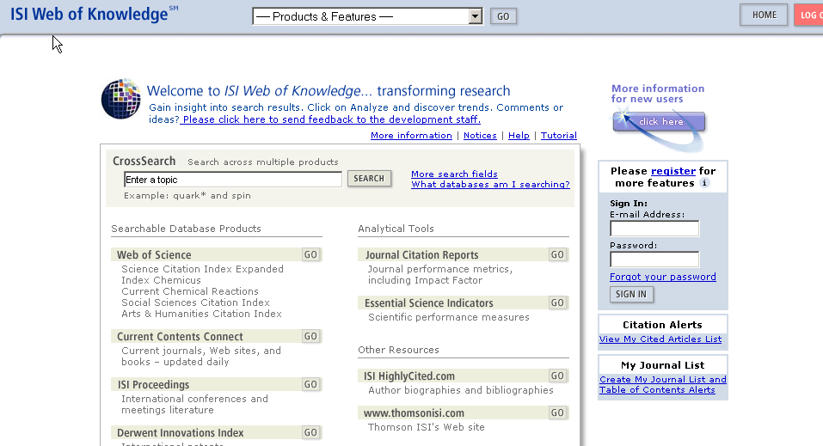
By Registering you get additional functionality that would not be available to you otherwise.

Registration
The benefits of registration are many. When you register you are allowed to use the features of the Web of Knowledge to a much greater extent. You will be able to create and save email alerts such as
The alerts that you can create are dependant on your institution’s subscription.
Alerts are not available for Journal Citation Reports.

Possibly the best advantage of Alerting is that you reserve space for yourself on a Thomson Scientific server. This means that wherever you log in from, if you are within your institution’s authorized IP range, your searches will follow you. You will not need to remember where you saved them.

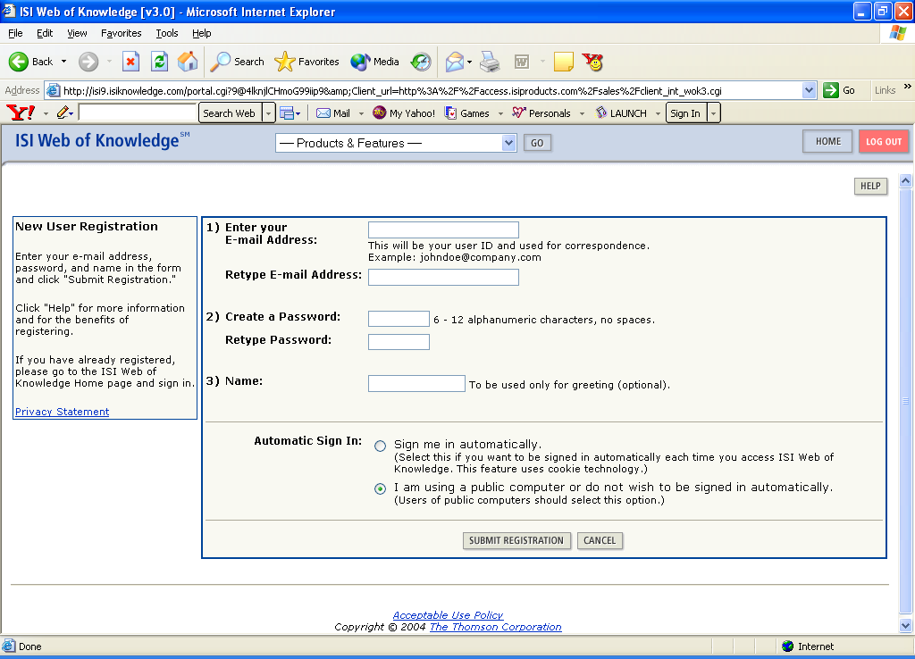

Registration is simple. You only have to enter your email address twice and create a password to gain the extra features.

Cross Search

As well as accessing your subscribed databases you will also have access to free of charge databases (External Collection) via Cross Search. These databases can be access simultaneously with the subscribed databases.

What databases am I searching?

Biological, Medical & Agricultural Sciences –
Agricola, PubMed, and arXiv.org Quantitative Biology archive.
Engineering, Computing & Physical Sciences- AIIA Meeting Papers, arXiv.org e-print archives (Computer Science, Mathematics, Nonlinear Sciences, Physics) ASCE Civil Engineering Database, NASA Astrophysics Data System (ADS) and NTIS Library
Social & Behavioral Sciences-
Popline, The Educator’s Reference Desk (Ask Eric)

Allows you to select which edition of JCR you wish to search (Science or Social Sciences) and the year of the edition.

Quick Search
Weekly update
Chemistry Plug-in
CrossSearch and the External Collections
Databases within Web of Knowledge can be accessed by clicking on the database name or by using the drop-down menu

Home Page

From the Home Page you can view
- View All Journals
- Search for a Specific Journal by using Full Journal Title, Abbreviated Journal Title, Tile Word or ISSN
- View a group of Journals by Subject Category, Publisher or Country

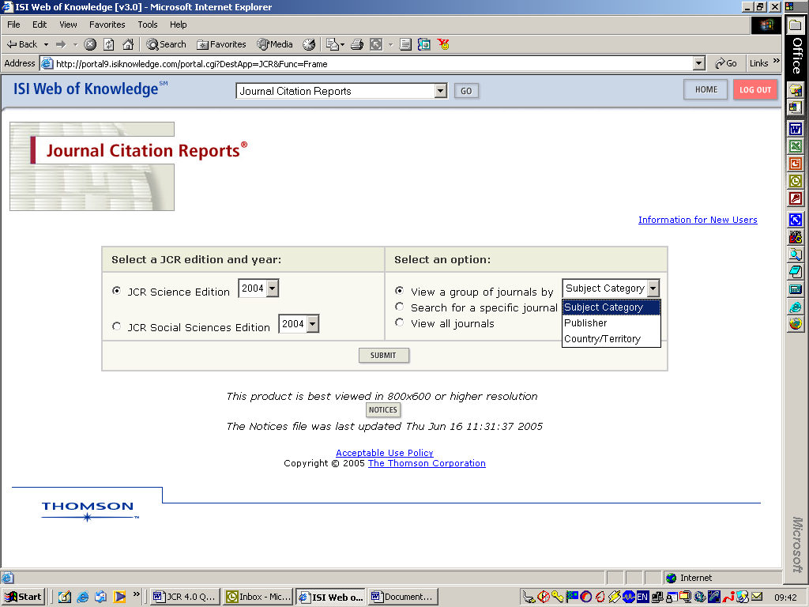
Choose how you wish to search/browse journals.
Select Edition & Year
View & Search Options

The most common way to view journals in the JCR is to group them by subject category. You may wish to compare information such as Impact Factor and Immediacy Index for journals within a certain subject category.

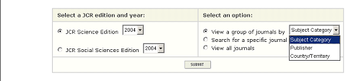

Search Tip

It is advisable that you stay within one Subject Category or related subject areas. The reason for this is that different Subject Categories have different Citation Cycles. This means that it may take longer for a paper to be cited in one category than another. It is there not wise to compare journals from completely different categories. Multiple categories may be selected by holding down the Control key when clicking each category.
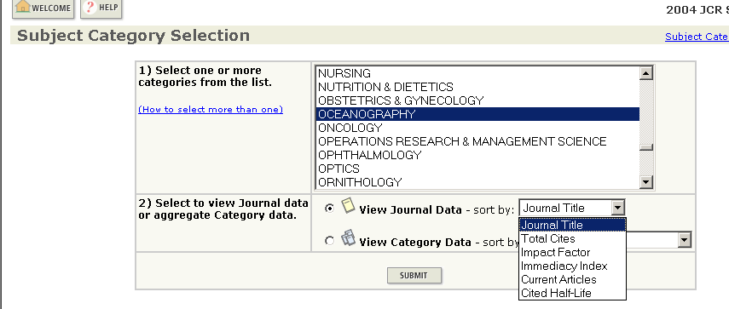
Sort journals by:
- Journal Title
- Total Cites
- Impact Factor
- Immediacy Index
- Current Articles
- Cited Half-Life

You can also choose to Search for a journal or journals by Full Journal Title, Abbreviated Journal Title, Title Word or ISSN
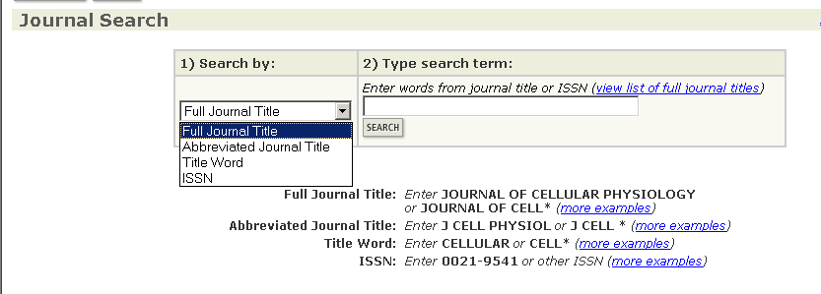

View Summary Display

When you select a Subject Category or associated Subject Categories you will see the results shown on a summary page sorted in the manner that you had originally selected. You can choose to sort by other attributes.

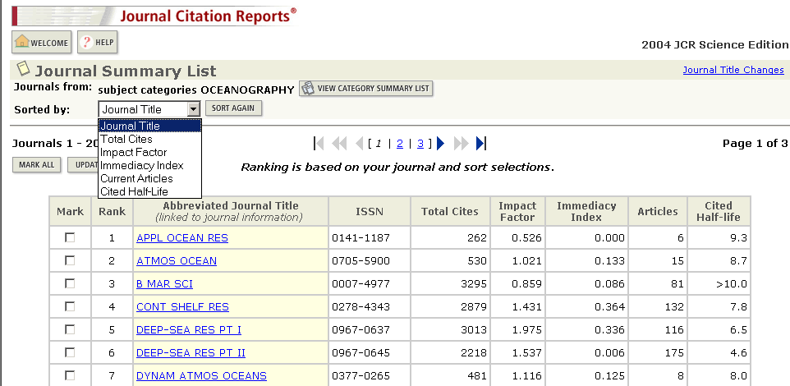
Resort the results

You can Mark All Journals or Selected Journals so that the data can be exported to file.

There is a link to Journal Title Changes which have occurred in the past 2 years. It Shows
- New title(s)
- Superseded title(s)
- Type of change (change, split, merge)
- Year change occurred

The data that you see in this summary display is as follows

Abbreviated Journal Title - This is hyper-text linked to the full record for that journal
ISSN – International Standard Serial Number
Total Cites – The number of times articles in a particular journal have been cited in the JCR edition year.
Impact Factor – An average number of citations a paper over a 3 year period (see page 8)

Immediacy Index – The number of times articles in a journal have been cited in the same year as they have been published (see page 8)
Articles – The number of articles published in the JCR edition year for that journal.
Cited Half Life – The number of years you have to back track to find articles that make up 50% of those articles which have been cited. (see page 9).

Full Record Display

Select a Journal from the Summary Display
Summary Information
You will now see the Full Display
Journal Information

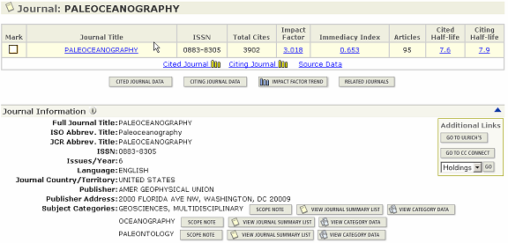
Subject Categories, Summary Lists & Scope Notes

In the Full Display you can see the following

Summary Data - as in the Summary Display (see page 6)
Cited Journal Data - Which journals are citing articles in this journal (see page 11)
Citing Journal Data - Which journals this journal is citing articles in (see page 11)
Impact Factor Trend - Graph showing last 5 year’s Impact Factors (se page 12).
Related Journals – Which journals have semantic relationships with this one due to having cited each other (see page 12)
Journal Impact Factor – (see page 8)
Journal Immediacy Index – (see page 8)
Journal Cited Half Life + Graph – (see pages 9)
Journal Citing Half Life + Graph - (see pages 10)
Journal Source Data – The number of Review and Non-Review articles published in that year in that journal and the number of references contained in the bibliographies of those articles.
View Journal Summary List – allows you to move between Subject Categories that this journal is assigned to, to see that journal’s standing in any other categories that it may be assigned to.
Scope Notes – Shows you what area each Subject Category covers for each of the Subject Categories that the journal is assigned to.
View Category Data – allows you to see the Aggregated Data for a particular Subject Category that the journal is assigned to (see page 14).
Journal Impact Factor
This is the most well-known statistic that comes from the JCR and should be used in conjunction with other statistical data provided in the database. It shows the recent history of the journal.
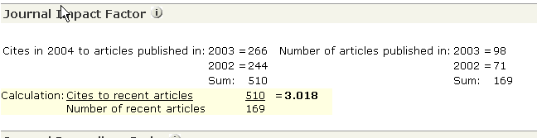
The calculation used in the Journal Impact Factor is quite simple.
- It looks at how many times articles published in the 2 years prior to the JCR edition year (here it is 2004) have been cited in the JCR edition year.
- It then divides the number of citations to these articles by the number of articles published in those 2 years.
- It basically shows an average citation rate per article for the past 2 years and so indicates how articles have performed in the journal since their publication.
- It should be noted that only research papers (articles) and review articles are considered in the calculation of the denominator. Letters, editorials etc are not taken into account. However, the numerator reflects citations to all document types.
Journal Immediacy Index
Applications

- Librarians can use the Impact Factor to help decide which journals to subscribe to.
- Authors can view the Impact Factor and decide which journals they may wish to submit their papers to for publication.
- Students can check the Impact Factor to see which journals they should be reading.
- Editors can check their journals’ Impact factors especially after any policy changes to see if the change has benefited the journal or not.
- Publishers can keep track of their own journals’ evaluations and those of their competitors.
- Administrators can see the standard of journals that their academics are publishing in.

The Journal Immediacy Index shows how many times papers published the JCR edition year have been cited in that same year.

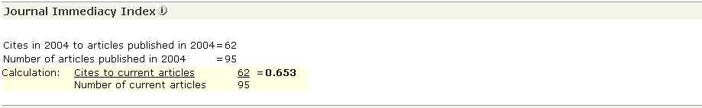

The total number of times articles published in a journal in the JCR edition year have been cited in that same year is divided by the number of articles published in that year.

As with Journal Impact Factor it only takes into account Articles and Review Articles for the denominator.

If a journal’s articles have not been cited in the same year that they were published then the Immediacy Index is zero.

The Journal Immediacy Index shows which journals are publishing “hot” or cutting edge articles.

Journal Cited Half Life

The Journal Cited Half Life looks at the number of Total Cites received by the journal in the JCR edition year irregardless of when the Cited Articles were published. It is only available if the journal has been cited more than 100 times in the JCR edition year.

First you take the Total Cites made in the JCR edition year

You see what percentage of those Cites were made to articles published in the JCR edition year.

You see what percentage of Total Cites were made to articles published in the JCR edition year and the previous year together. This continues adding on years and looking at the cumulative percentage until it reaches 50%. This is the Cited Half Life and is measured in terms of years and fractions of years.
- This information is expanded to show these calculations at individual journal level in Cited Journal Data (see page 11).
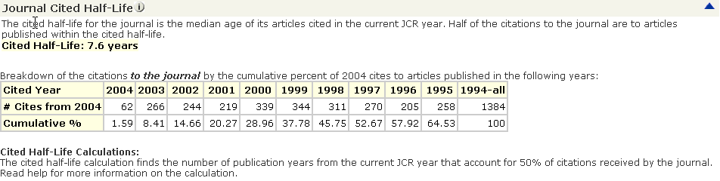
No of Cites per year

Cumulative Cites

Applications

- You use the Journal Cited Half Life to see if articles from a journal that were published a long time ago are still being cited. The maximum Journal Cited Half Life is >10 years. This shows you if the journal has a good track record and was producing good articles in the past.
- The Journal Cited Half Life may be useful to library staff in order to carry out collection management. If a journal has a low Cited Half Life it means that older papers are not being cited as much and it may be a reason for not binding these into volumes and archiving them.

Cited Journal Graph

This shows a graphic interpretation of the data from the Journal Cited Half Life table. It also shows the number of times that articles from within a journal cite other articles from that same journal.
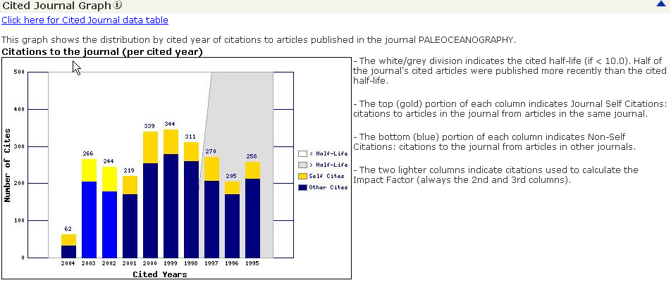
Self Citations are shown in Yellow.
The White/Grey partition shows where the Cited Half Life is found

Journal Citing Half Life
The Journal Citing Half Life shows how far back the journal that we are studying is citing articles. This is basically the opposite of the Journal Cited Half Life. The data is taken from Journal Source Data table which shows the number of Articles/Review Articles and the number of items in their bibliographies.
This is shown in tabular format as Journal Cited Half Life and graphically as Citing Journal Graph

This information can be found broken down to journal level in Citing Journal Data (see page 11).

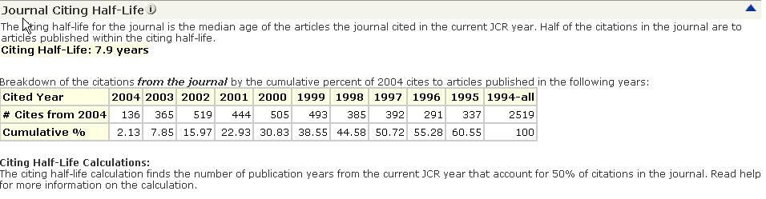
Applications

By knowing how far back the journal cites you can see if the journal is citing the most up to date, cutting edge literature or older literature and so can decide if this journal is valuable in helping you keep up to date in your research area.
In general Cited Half Life and Citing Half Life are very close in value. If there is a large difference in the number of years it could show that a journal is citing the latest literature but its older literature is mostly being cited or vice versa.

Citing Journal Graph

This shows a graphic interpretation of the data from the Journal Citing Half Life table. It also shows the number of times that articles from within a journal cite other articles from that same journal.

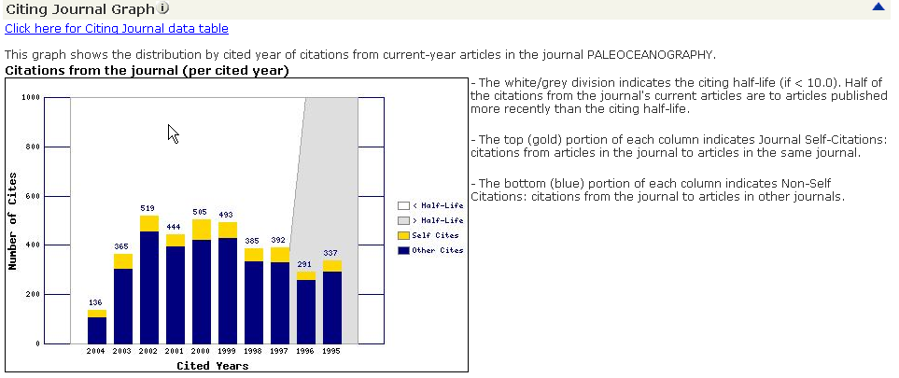
The White/Grey partition shows where the Citing Half Life is found
Self Citations are shown in Yellow.

Cited Journal Data

Cited Half Life data shows you which journals have been citing the Parent Journal over a 10 year time period.

It helps establish relationships between journals according to subject area through citation patterns and distribution.
Citations for All Years and for Individual years
All Others indicates journals that have only cited articles in this journal once.
Citing Journal Data
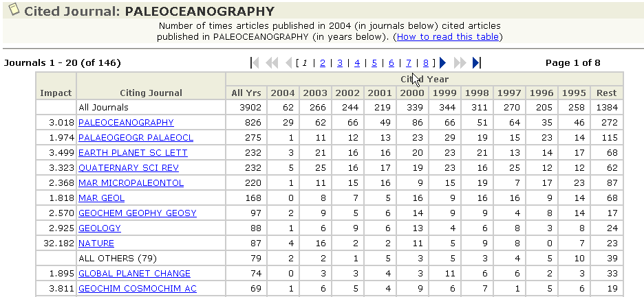

Citing Half Life data shows you which journals the Parent Journal has been citing the over a 10 year time period.

It helps establish relationships between journals according to subject area through citation patterns and distribution and should be used with the Cited Journal Half Life to achieve that purpose.
Citations for All Years and for Individual years

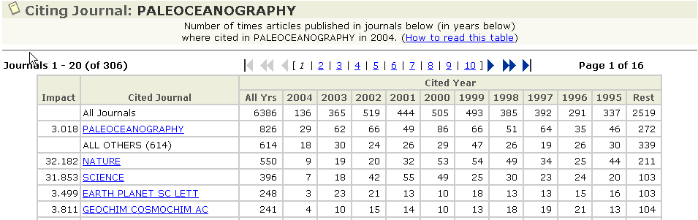

Impact Factor Trend

The Impact factor Trend graph shows a bar chart of the last 5 years Impact Factors. This graph is linked from Web of Science and Current Contents Connect depending on your institution’s subscription.
As the Impact Factor is graphically shown over a time period it shows if the journal is improving or not in an easy to view manner and can help in both subscription and paper submission decisions.

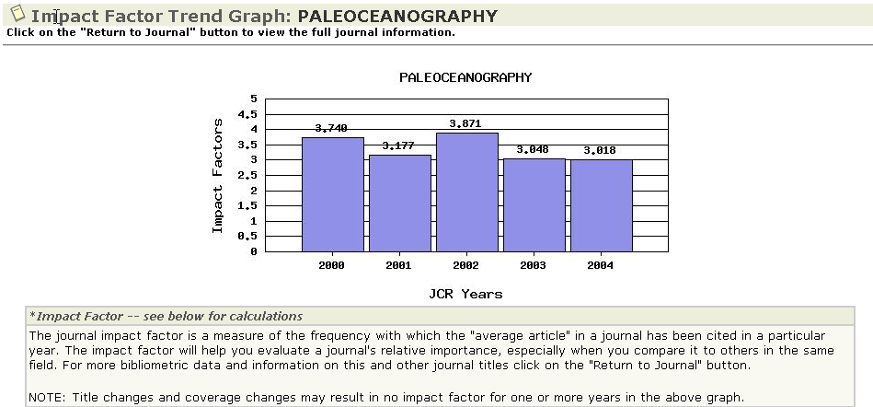

Related Journals

Related Journals shows how a journal is semantically related to other journals based on citation information. It shows the Citation Density between 2 journals by considering the number of citations going from one journal (i) to another journal (j).
Parent Journal

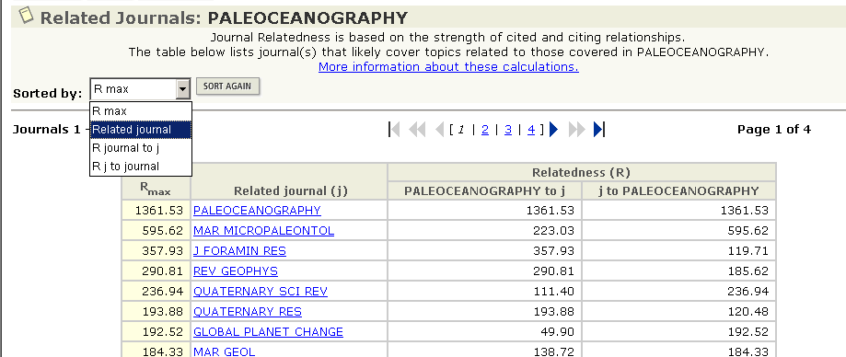
^{R}max value is the higher of the two values in the columns showing relatedness.
Relatedness from Parent journal in terms of citations to other journals
Relatedness from other journal in terms of citations to Parent journal
Sort by Journal Name or Relatedness

The calculation used to show relatedness is taken from the Cited and Citing Journal Data (see page 12). In theory the calculation is as follows where i is the parent journal and j is the other journal. The results of these calculations are known as R values.

Citations from i to j * 10⁶
Papers in j * References in i.
In practice if we were looking at the relationship between Paleoceanography (i) and Marine Geology (j), the calculation would be.

163 (citations from Paleoceanography to Marine Geology) * 10⁶
184 (papers in Marine Geology) * 6386 (total references in Paleoceanography) = 138.72
To calculate the relationship from Marine Geology (j) to Paleoceanography (i) you would switch the calculation to be
Citations from j to i * 10⁶
Papers in i * References in j.

And this would be

168 (citations from Marine Geology to Paleoceanography) * 10⁶
184 (papers in Paleoceanography) * 6386 (total references in Marine Geology) = 184.33

Comparing these R Values shows that Marine Geology has a stronger relationship to Paleoceanography than vice versa and so the R value for Marine Geology is the ^{R}max.

The data that is shown in the table on the last page shows the relationships of the parent journal to other journals and the relationship from other journals to the parent journal expressed as a number derived by these 2 calculations. The higher of these 2 numbers is called ^{R}max. The higher the value of ^{R}max, the stronger is the subject connection between the parent journal and the other journal.

Related Journals data are available only for journals that have been cited more than 100 times in the JCR edition year. Also, R values per journal pair are calculated only if each journal cites the other at least two times

The calculation that is used here was developed by our founder Dr Eugene Garfield in conjunction with Alexander Pudovkin in Algorithmic Procedure for Finding Semantically Related Journals, 3rd September 2002,Journal of the American Society for Information Science and Technology, v53, i1, p1113-1119. This paper can be found at http://garfield.library.upenn.edu/papers/pudovkinsemanticallyrelatedjournals2002.html

Applications
- For Information Specialists this can help to select groups of Related journals to subscribe to.
- For Author it gives a list of journals in their subject area that they may wish to subscribe to.
- For Publishers it helps them keep track of competitors in their subject area and also can help to find possible authors.
- It also can give a list of Related Journals from various subject areas that you may wish to compare Impact Factors of.

Subject Category Data
The sections that follow concern aggregate data for all journals within one subject category.

Subject Category data brings together all the data for each individual journal within that category. This helps to see how each Subject Category compares to another category within the database and how journals compare to other journals in the category.

This can be accessed via the initial Subject Category Selection screen (see page 6) or from the Full Record Display for a journal within that category. (see page 7).
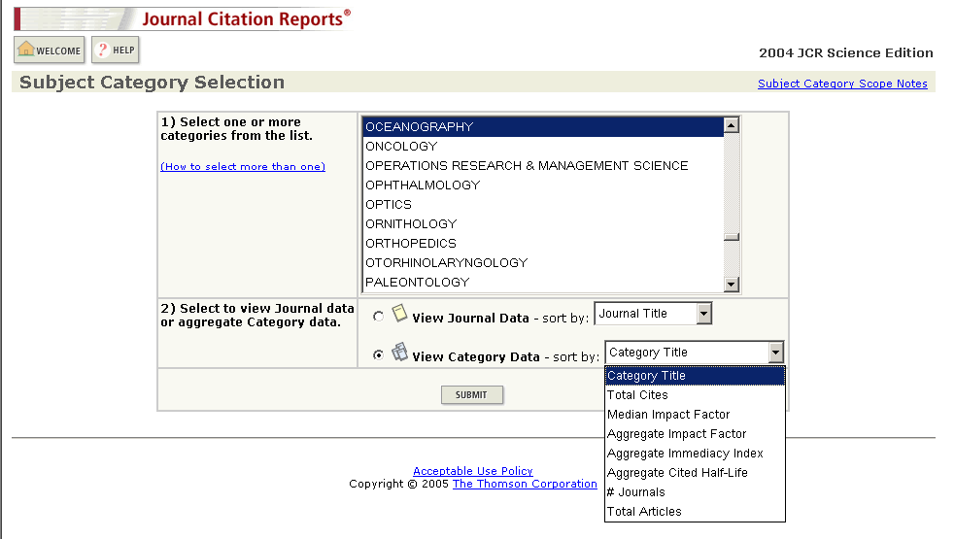

Once the Subject Category has been selected then the data can be sorted by Category Title, Total Cites, Median Impact Factor, Aggregate Impact Factor, Aggregate Immediacy Index, Aggregate Half Life, Number of Journals and Total Articles.

From the Full Record Display you can also see the Subject Category data.
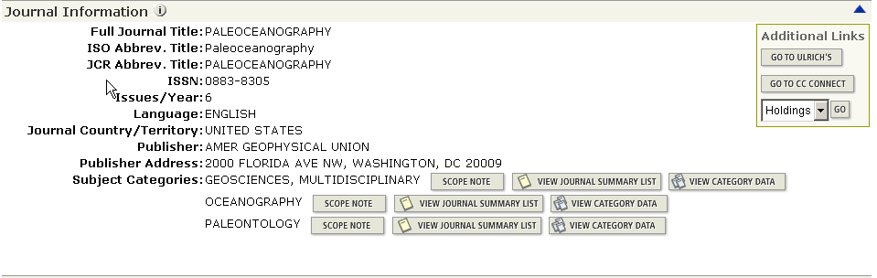
View Category data from the Full Record Display

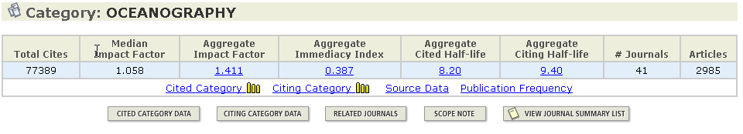
Total Citations for All Journals in the Category
Number of Journals and Articles in this Category

The Subject Category Data contains

- Total Cites in the JCR edition year for all journal in that Subject category
- Median Impact Factor which is the Impact Factor of the middle journal in this Subject Category if the journals are sorted by Impact Factor (see page 15).
- Aggregate Impact Factor (see page 16)
- Aggregate Immediacy Index (see page 16)
- Aggregate Cited & Citing Half Life (see page 17)
- Related Journals (see page 17)
- Cited Citing Category (see page 18)
- Source Data (see page 19)
- Publication Frequency (see page 19)

Median Impact Factor

The Median Impact factor takes into account all journals within a Subject Category. The journals are sorted by Impact Factor with the highest Impact Factor being treated as the top journal. The system then looks for the middle journal by Impact Factor in the journals for this Subject Category. This represents the Median Impact Factor.

In the example used here, in the Subject Category “Oceanography”, there are 41 journals in the JCR 2004 edition. If these are sorted by Impact Factor then the Median Impact Factor will be the Impact Factor of the 21st journal which is Estuarine, Coastal & Shelf Science
Median Impact Factor for Subject Category “Oceanography”

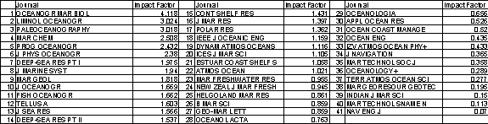

Aggregate Impact Factor

The Aggregate Impact Factor looks at all citations made to Articles and Review Articles made to all journals in the JCR edition year to articles published in all the journals in that category in the previous 2 years.

This helps to be able to judge one journal from that category against the average Impact Factor for other journals in that category and shows you the “average” citation behavior of articles in that Subject Category.

This works the same as Journal Impact Factor but at the Subject level.
Cites to All Journals in the Subject Category

Number of articles published in All Journals in the Subject Category

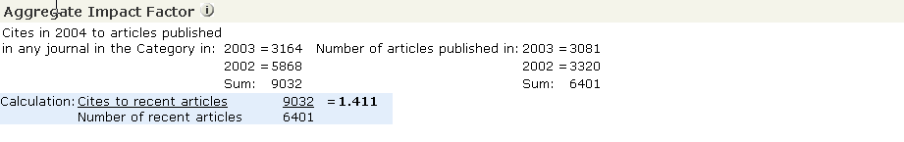

Aggregate Immediacy Index

As with the Aggregate Impact Factor this information takes into consideration Citations made in the JCR edition year to articles published in that same year in All Journals in the particular Subject Category.

It helps to see how quickly journals on average are cited in that Subject Category and so see if this is a “fast-moving” subject area.

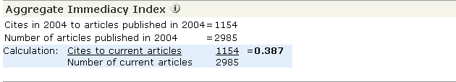

Aggregate Cited & Citing Half Life

As the Aggregate Impact Factor show the time period in which it takes articles to gain 50% of the Total Citations for all journals in that category.

It helps show if articles in that category are still citing articles in both that same category and other categories for an extended period or just recent articles.

Cited Half Life shows how far back the articles in that category are being cited and Citing Half Life shows how far back articles in that category are citing.

As with Cited & Citing Half Life for journals this comes with a graphical representation in the Cited or Citing Category graph but this does not show “self citations’ as these are limited to individual journals.

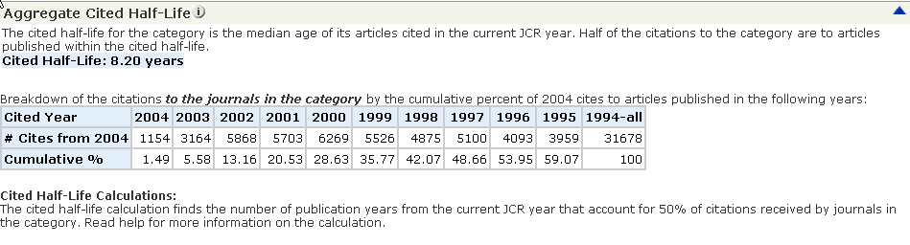

Related Journals (in Category)
Whereas Related Journals (see page 12) refers to the relationship between a “Parent” journal and other journals either within or outside of the category, this Related Journals function compares individual journals with the Aggregate information for All of the journals in the Subject Category.

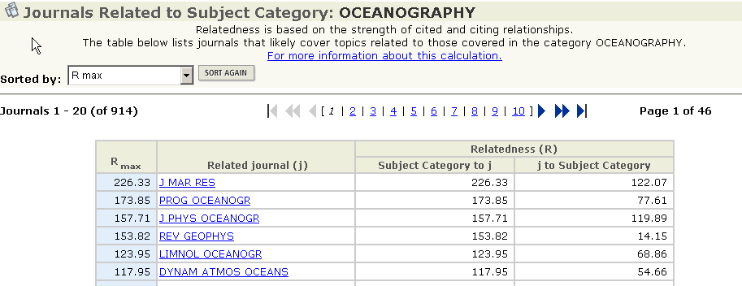

As with Related Journals at an individual journal level the information comes from the Cited Data in this case Cited & Citing Category Data (see page 18).

The calculation used is similar and is

Citations from n to j * 10⁶
Papers in j * References in n.

Where n replaces the i and so the data for the parent journal is replaced by the aggregate data for all journals in same category.

In the example of the Subject Category “Oceanography” the calculation would be as follows.

898 (citations from Subject “Oceanography” to J. Marine Research) * 10⁶
184 (papers in J Marine Research) * 118800 (total references in Subject “Oceanography) = 226.33

We can also see the opposite relationship between the journal (J. Marine Research) and the Subject Category.

587 (citations from J. Marine Research to Subject “Oceanography”) * 10⁶
2985 (papers in Subject “Oceanography”) * 1378 (total references J Marine Research) = 122.07

Comparing these R Values shows that the Subject “Oceanography” has a stronger relationship to J Marine Reseach than vice versa and so the R value for “Oceanography” is the ^{R}max.

This helps to identify the relationship between an individual journal and the journals as a whole in that Subject Category and so gives a big picture of how a journal fits into one or more categories.

Cited & Citing Category Data

As with Cited and Citing Journal Data (see page 11), Cited & Citing Category Data give us an idea of which journals are citing articles from journals within a category so showing the which journals are most active within that category and also outside that category.

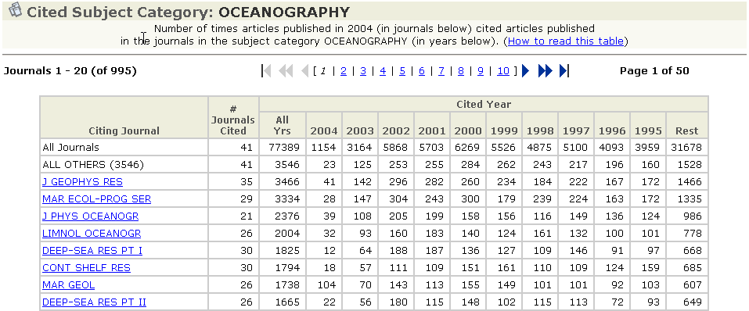

As with Cited & Citing Journal Data this shows citation data over a 10 year period. All Others in this case means all journals that have cited articles in this category only once (for Cited Category) or all journals that have been cited only once by articles in this category (for Citing Category).

Source Data (in Category)
Source Data shows how many Articles & Review Articles have been published in All journals in that Subject category and how many references were contained in those “articles” bibliographies or reference lists.

Publication Frequency

This very simple table and graph shows how often journals within that Subject Category publish

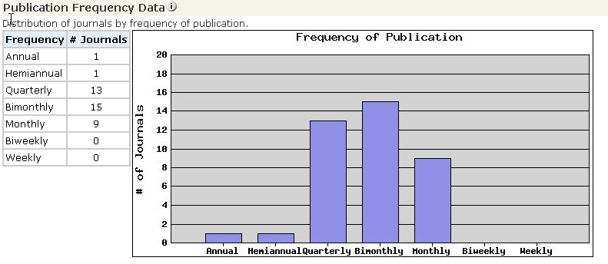

Contact Details

Americas
3501 Market Street
Philadelphia, PA 19104
USA
Phone: +1 800 336 4474
+1 215 386 0100
Fax: +1 215 386 2911
Japan
Thomson Corporation K.K
Palaceside Bldg. 5F
1-1-1 Hitotsubashi, Chiyoda-ku
Tokyo 100-0003
Japan
Phone: +81 3 5218 6500
+81 3 5218 6530
Free dial: 0800 888 8855 (from Japan only)
Fax: +81 3 5218 6536
Web: www.thomsonscientific.jp
Asia Pacific
Six Battery Road #29-03
Singapore 049909
Phone: +65 6879 4118
Fax: +65 6223 2634
Australia
Level 5
100 Harris Street
Pyrmont, NSW 2009
Australia
Phone: +61 2 8587 7948
Fax: +61 2 8587 7848
Toll Free Phone: 1800007214 (Australia)
0800443162 (New Zealand)
India
Pinnacle #15
Bahai’s Bhavan Road
(formerly Commissariat Road)
Bangalore 560 025
India
Phone +91 80 25550333 etx. 3322
Fax +91 80 25323979
Other Thomson Scientific Offices
Beijing, People’s Republic of China
Seoul, Republic of Korea
Taipei, Republic of China

Please visit our corporate website and Customer Support Center for more information for our products and services
Corporate Website: www.scientific.thomson.com
Customer Support Center: www.scientific.thomson.com/support
Should you need any technical assistant, please contact our helpdesk at:

China – ts.support.china@thomson.com
Japan – ts.support.jp@thomson.com
Korea – ts.support.korea@thomson.com
Rest of Asia – ts.support.asia@thomson.com

